**DAILY ONLINE ACTIVITIES SUMMARY**

|  |  |  |  |  |  |  |  |  |
| --- | --- | --- | --- | --- | --- | --- | --- | --- |
| **Date:** | **03/05/2020** | | | | | **Name:** | **POOJA D S** | |
| **Sem & Sec** | **4th SEM 'B' Section** | | | | | **USN:** | **4AL18CS056** | |
| **Online Test Summary** | | | | | | | | |
| **Subject** | | **Object Oriented Concepts** | | | | | | |
| **Max. Marks** | | **30** | | **Score** | | | **14** | |
| **Certification Course Summary** | | | | | | | | |
| **Course** | **Computer Vision Essentials** | | | | | | | |
| **Certificate Provider** | | | **Great Learning Academy** | | **Duration** | | | **5.5 hour** |
| **Coding Challenges** | | | | | | | | |
| **Problem Statement:** A user will input two strings, and we find if one of the strings is a sub sequence of the other. Program prints “yes” if either the first string is a sub sequence of the second string or the second string is a sub sequence of the first string. Assume that, the length of the first string is smaller than or equal to the length of the second string. Assume that, the length of the first string is smaller than or equal to the length of the second string. | | | | | | | | |
| **Status: completed** | | | | | | | | |
| **Uploaded the report in Github** | | | | | **Yes** | | | |
| **If yes Repository name** | | | | | <https://github.com/dspooja/Java-coding>  <https://github.com/dspooja/C-coding> | | | |
| **Uploaded the report in slack** | | | | | **Yes** | | | |

Online Test Details: (Attach the snapshot and briefly write the report for the same)

Certification Course Details: (Attach the snapshot and briefly write the report for the same)

Coding Challenges Details: (Attach the snapshot and briefly write the report for the same)

ONLINE TEST DETAILS:

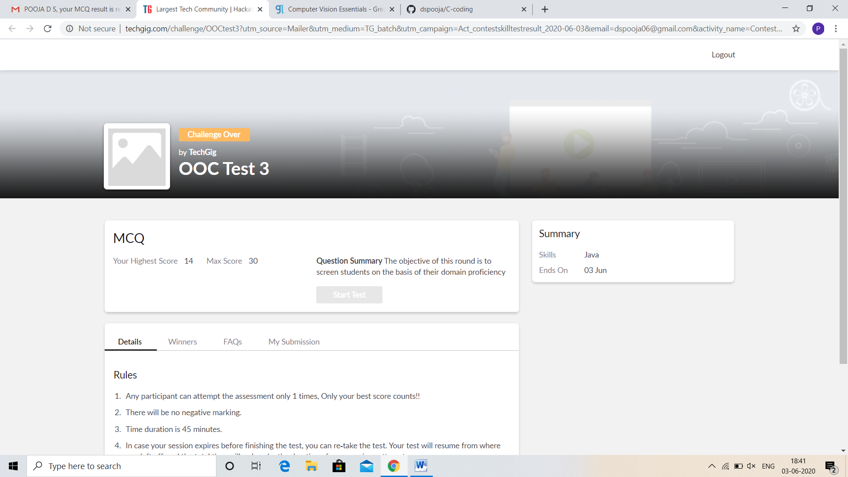

CERTIFICATION COURSE DETAILS:

* As continuation of the **Computer Vision Essentials** online course**.**
* **The concepts covered in Computer Vision Essentials are:**
* Transposed Convolution and Fully Connected Layer as a Convolution.
* Pooling: Max Pooling and Other pooling options.
* Hands-on Keras Demo: MNIST CNN Building Blocks code walk – through.

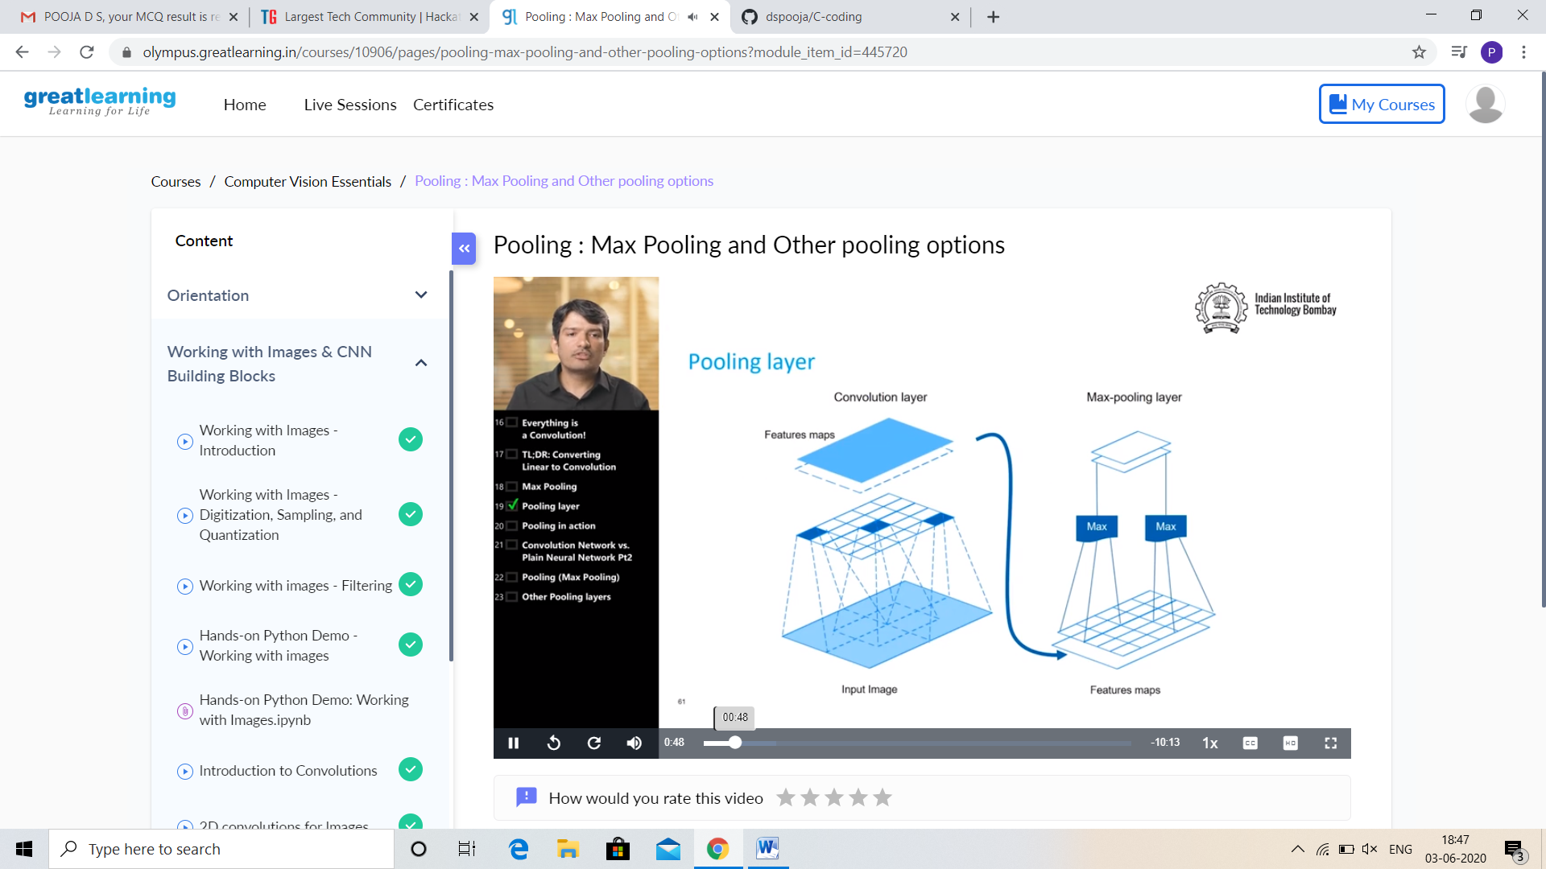

And today I complete Game development using PyGame, this is the Screen shot of my certificate.

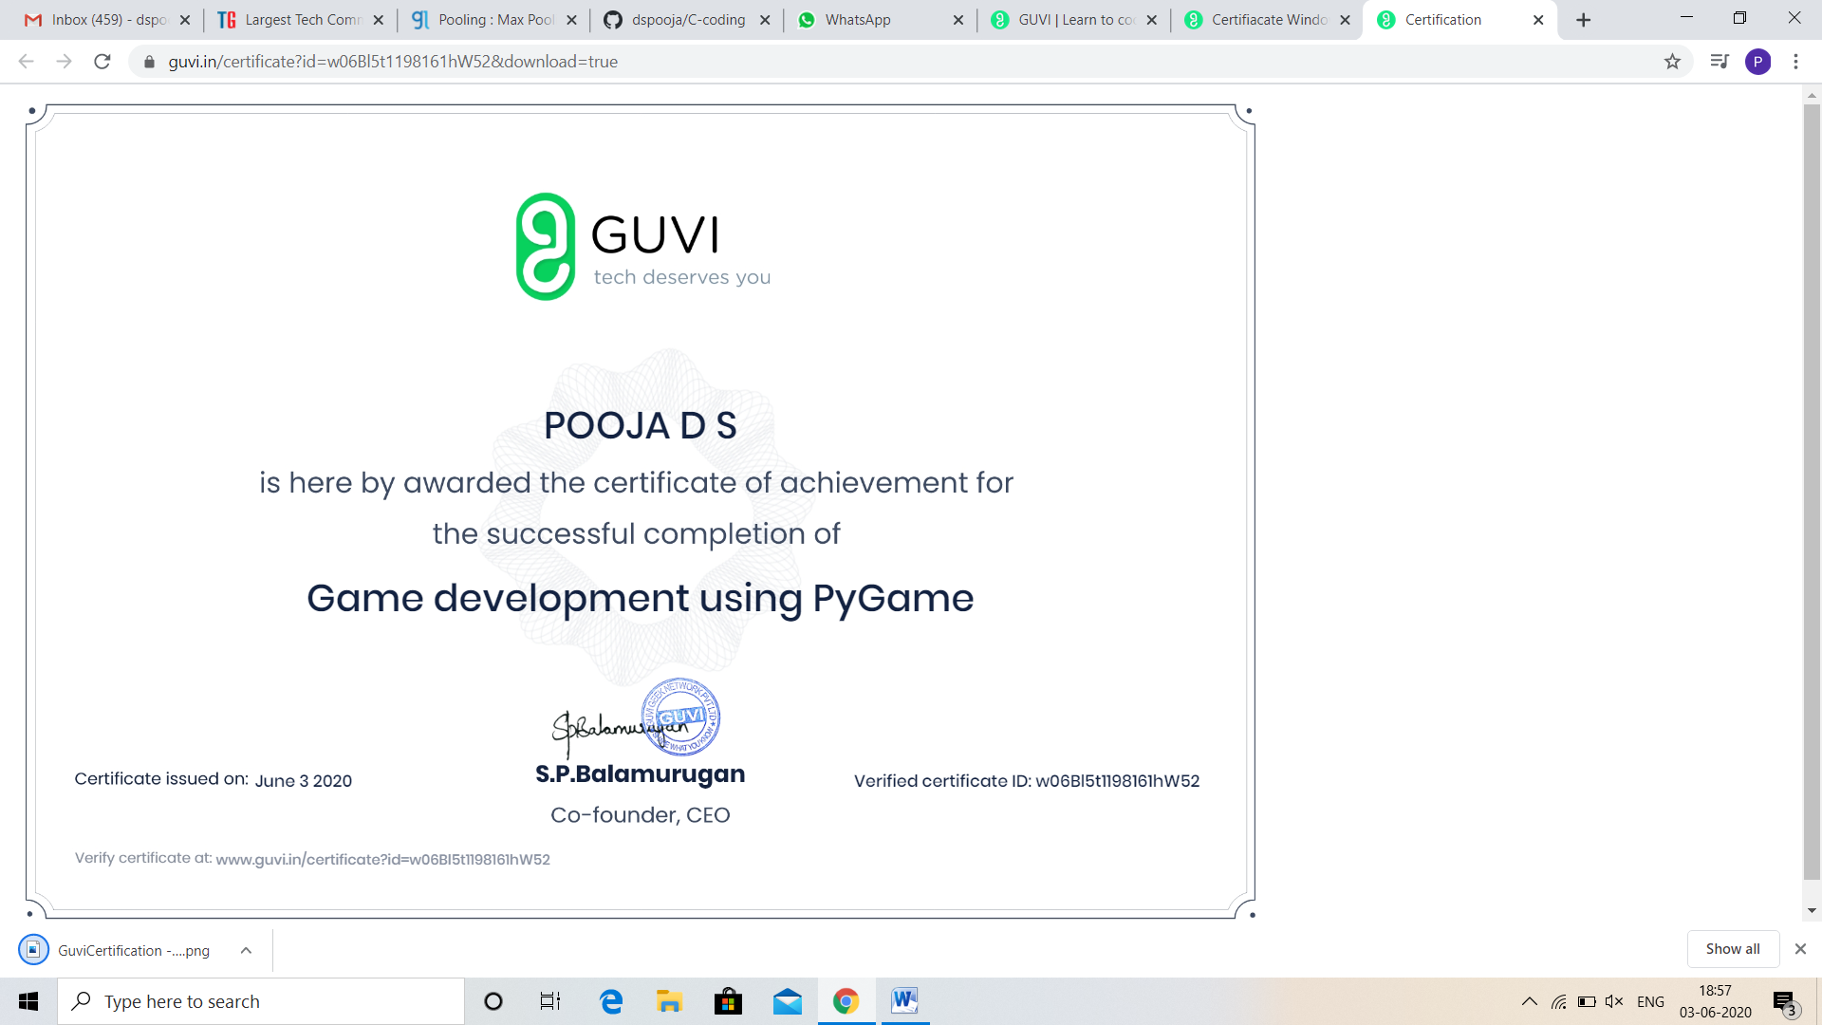

CODING CHALLENGES DETAILS:

Problem statement 1:

Write a Java program to find Last Digit of a^b (a to the power b) for Large Numbers.

You are given two integer numbers, the base a (number of digits d, such that 1 <= d <= 1000) and the index b (0 <= b <= 922*10^15). You have to find the last digit of a^b.

Examples:

Input : 3 10  
Output : 9

Input : 6 2  
Output : 6

Solution : Uploaded it in github

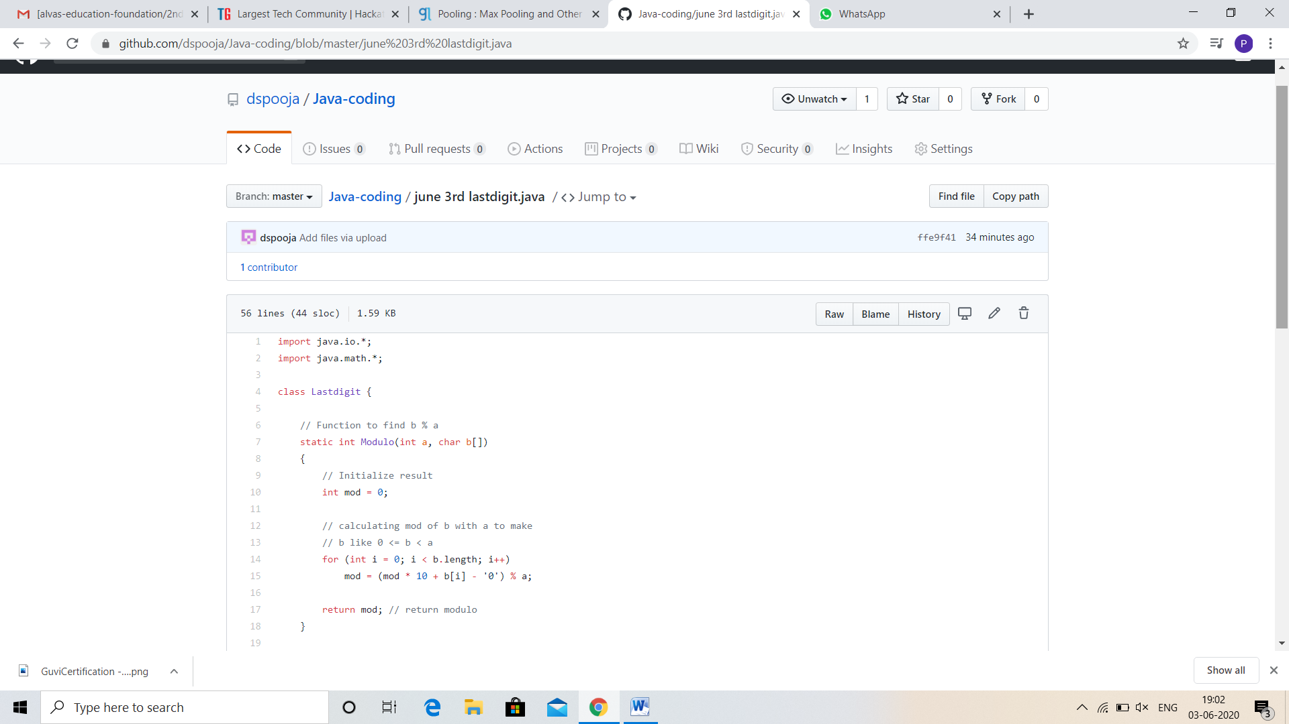

Problem statement 2:

JAVA PROGRAM

Write a code segment in java to swap two numbers using call by object reference.

Solution: Uploaded in github.

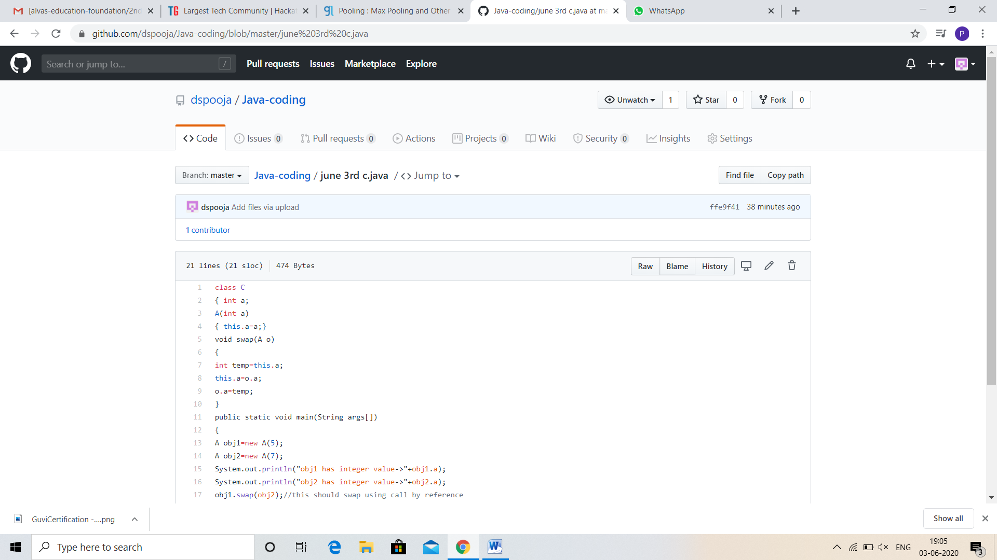

Problem statement 3:

Write a function that takes a two-digit number and determines if it's the largest of two possible digit swaps.

To illustrate: largestSwap(27) ➞ false largestSwap(43) ➞ true If 27 is our input, we should return false because swapping the digits gives us 72, and 72 > 27. On the other hand, swapping 43 gives us 34, and 43 > 34. Examples largestSwap(14) ➞ false largestSwap(53) ➞ true largestSwap(99) ➞ true

Solution : Uploaded it in github

